HR module

Existing screens have already been viewed.

  In general they represent good content but you need to rearrange many screens and delete some of them and add others

The following map can be used to build and design the HR module

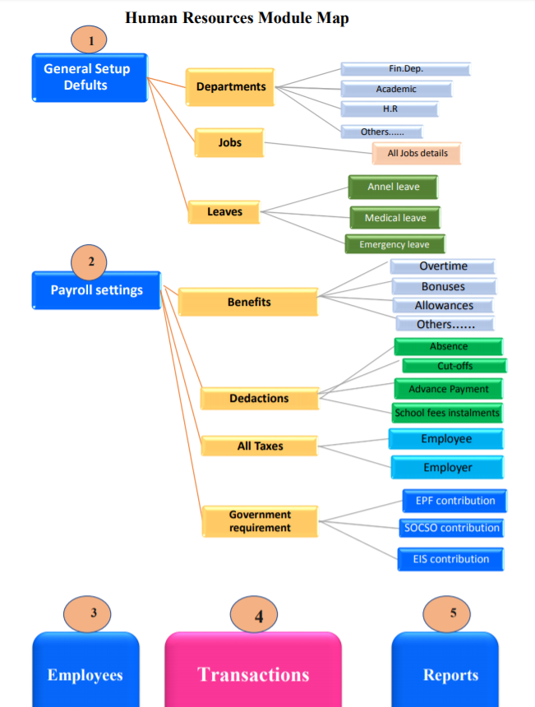

1- General Setup Defaults

Must include the main branches of the medium and this data is entered only once and includes the main sections and then jobs and then all kinds of leaves

And take into account all the existence of an icon for (New, Edit)

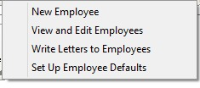

**2. Payroll settings**

As shown in the map include all benefits and deductions and all types of taxes and other government requirements and take into account the following

(A) sufficient flexibility in the addition or deletion of different types of preceding sections in order to suit the nature of each State;

B - show the different types added by default when you enter the data of a new employee ... ... with the possibility of changing exceptionally for a specific employee

Accounting note is very important

  Each hay of the sub-items in the third level in the previous map must be linked to its own account in the Accounts Guide (it can be selected and modified when you enter this item)

For example, the bonus is linked to his account in the accounts directory - the absence discount is linked to the account directory - the employees' advances are linked to the accounts directory and so on.

The following images can be used for implementation

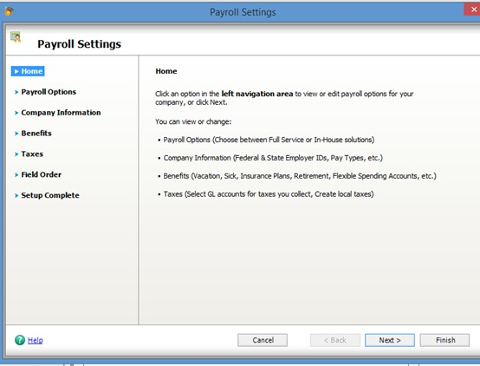

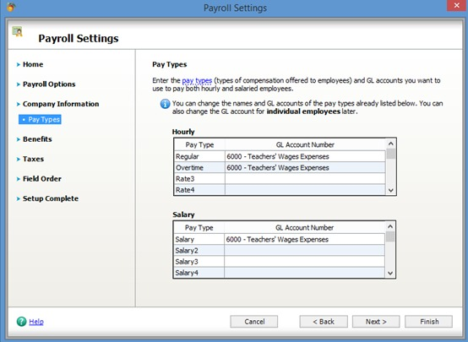

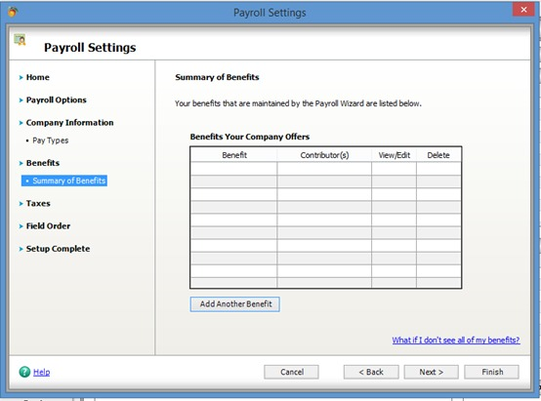

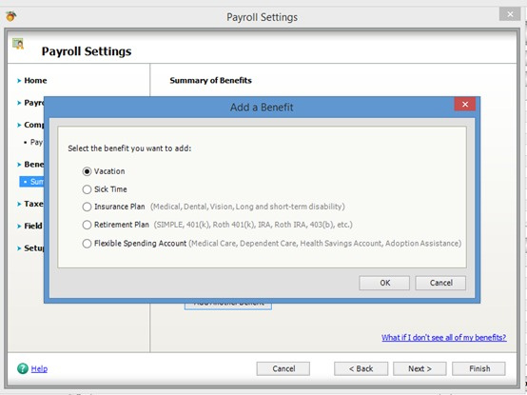

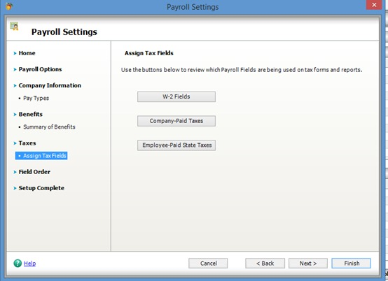

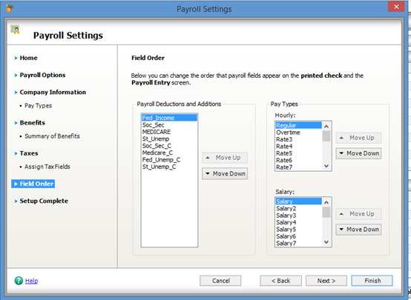

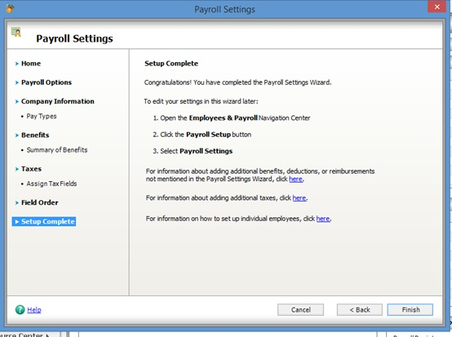

**3- Employees**

It includes recording staff data (currently on the system is good but needs to be reclassified entries into groups and can be guided further)

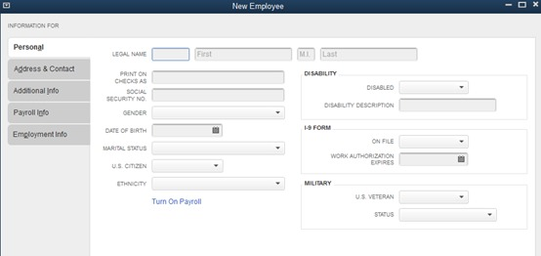

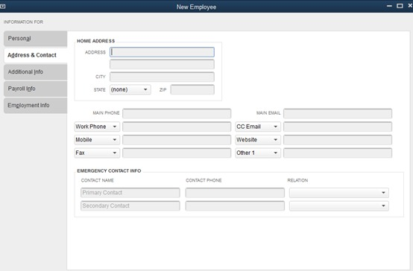

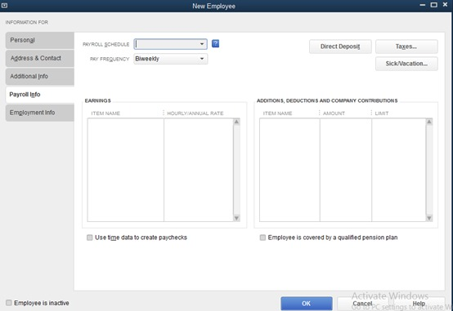

**4- Transactions**

Here the standard of ease must be taken into account because these processes will be repeated periodically

  Includes the introduction of vacations, discounts, bonuses as well as salaries and other ……

C:\Users\Hany\Desktop\5.jpg

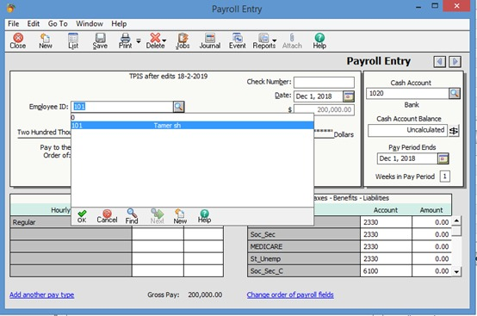

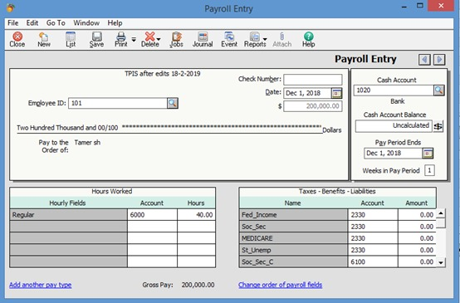

Or at the level of all employees at the end of the month (one screen in the form of a table is easy to fill his data for all employees at once)

Can be guided in this way with (change existing content)

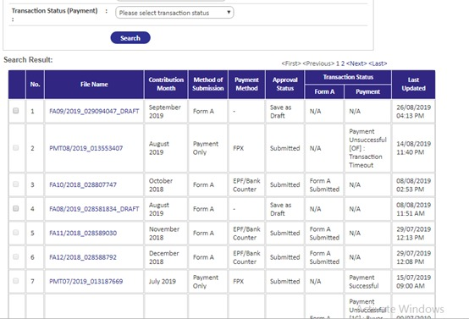

**Important Note in accounting in HR Module**

  Regarding this module in full …… .. **Daily entries** “Daily Journals” are not prepared except for the part in the icon No. 4 only and is responsible for the financial statements, the rest of the data is identifying data and is stored in the database for use in other purposes.

**5 -Reports**

The next page can be guided to build a different set of reports ... not necessarily all of them available

